**AHK VM Installation Guide**

Prerequisites for this installation:

1)JAVA 8 should be installed and configured in the Environmental path.

1) Download the Tomcat exe file from this url. <https://archive.apache.org/dist/tomcat/tomcat-9/v9.0.37/bin/>



2)Tomcat exe file downloaded in local folder.



3)Install the .exe file by doubl clicking on it.



4) Click Next-> I Agree



5) Click -> Next



6) set Port number,Username and Password.



7) Select the path of Java JRE installed in the machine



8)



9)Click Install-> Installation completed and give Finish.



10) Press Windows key+ r -> It will open Run command and type as below.



11) Apache Tomcat service is started running.



12)Open any browser and call this url to view Tomcat Manager page- <http://localhost:8080/>



13) Click ManagerApp button by entering the username and password to see the deployed applications. As this is a fresh installation no application are deployed yet.

Username:admin Password:admin123



14)Tomcat installation is ready, we can see how to deploy war file into this server.

Locat the Tomcat installation path.



15) Paste the ahkService.war file into this location. This will create folder with that name after successful deployment.



16) We can see the status of deployment in Tomcat Manager page.



17) Create a folder in anyof the location and paste the location in the below into the file.

Example:

i) Create a location and pasted the scriptfile.

**Location**: C:\Users\Viji.J\Documents\TAF_AHK



ii) Locate the deployed application folder and navigate to classes folder as below



iii) Open the application.properties file and paste the created location path in **AHK.path** and **logging.file.**

* Ensure the server.port is commented (Eg. #server.port)
* Logging file path should end with ahk.log (Eg . logging.file=<**base folder path>\\**ahk.log)

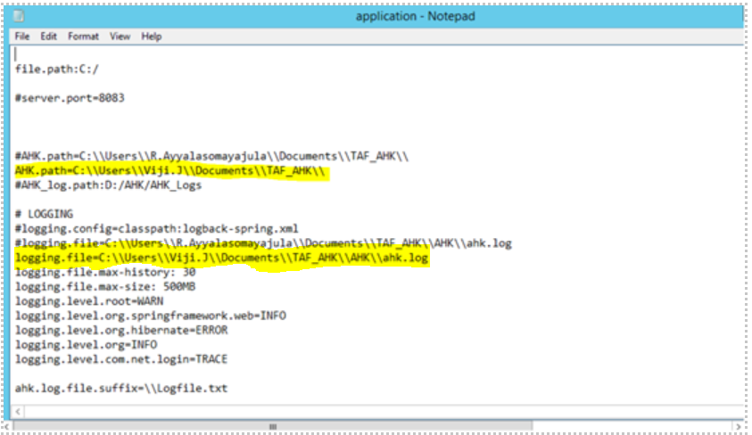

18) After changes in the properties file , need to reload the application in the tomcat Manager page.

Go to Tomcat Manager-> Locate the application(ahkService) -> On the right side click on the Reload button as highlighted below.



19) It will return the successul reloaded message like below. Ensure the Running status should be **true.**



**(i) Testing the Deployed application with Sample AHK in the Windows VM:**

1. Take the AHK script(Eg. NotepadExe.exe) and placed into the above mentioned folder(ahk.path= C:\\Users\\Viji.J\\Documents\\TAF_AHK)

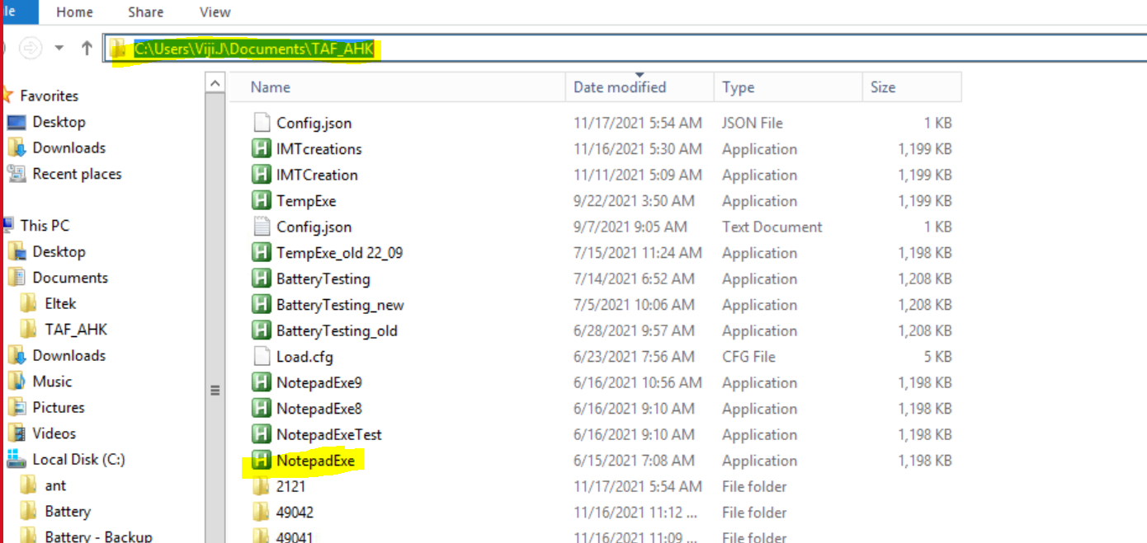

2. Once the above steps/validations are completed, we can do the sanity testing with the help of Git Bash. Open the Git Bash in the same Windows VM and execute the below cURL command.

URL: **http://<VM IP>:8080/ahkService/ahk**

**Ex:**

curl -i -X POST 'http://172.16.195.112:8080/ahkService/ahk' \

--header 'Content-Type: application/json' \

--data-raw '{

"orderType": "AHK",

"orderId": "2126",

"orderCreatedBy": "Logesh",

"subOrderId": 0,

"role": {

"roleId": 4

},

"suiteDetails": [

{

"suiteName": "AHK-Battery",

"botDetails": [

{

"botName": "NotepadExe",

"input": {

"Mail_To": "logesh.j@prodapt.com"

}

}

]

}

]

}'

Response should be 200, For this test script Notepad will open and close automatically. During this time do not close the opened Notepad, let it close.

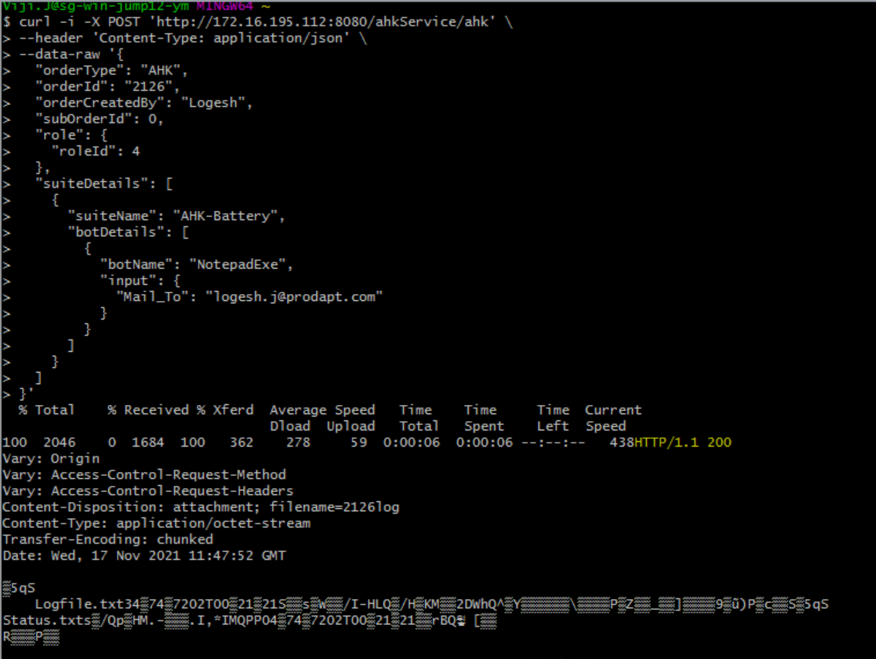

3. After getting success Execution, go to the AHK configured path and locate the folder created recently. Folder name will be taken from the OrderId which we passed in the cURL Request body.

curl -i -X POST 'http://172.16.195.112:8080/ahkService/ahk' \

--header 'Content-Type: application/json' \

--data-raw '{

"orderType": "AHK",

"orderId": "2126",

"orderCreatedBy": "Logesh",

"subOrderId": 0,

"role": {

"roleId": 4

..............

4. Folder is successfully created with the OrderId name.

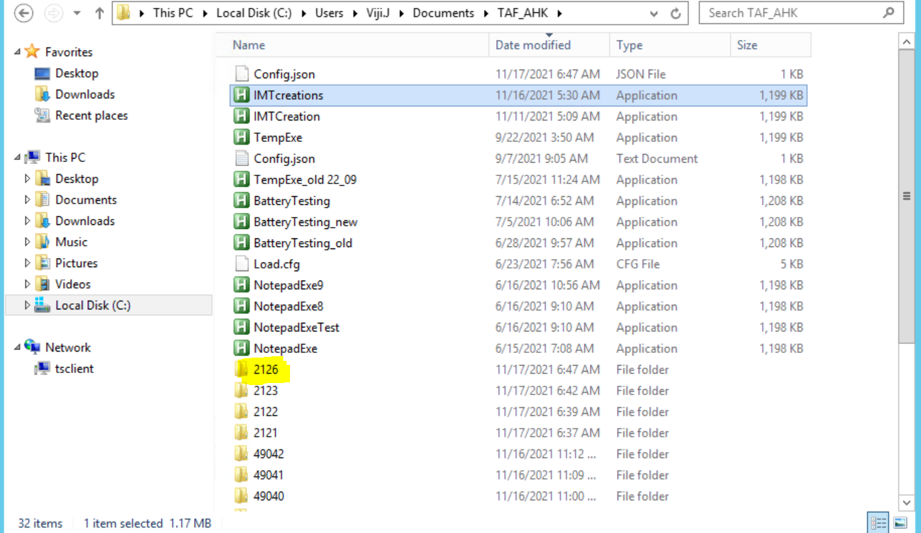

5. Click on the folder, you will see the files created as below.

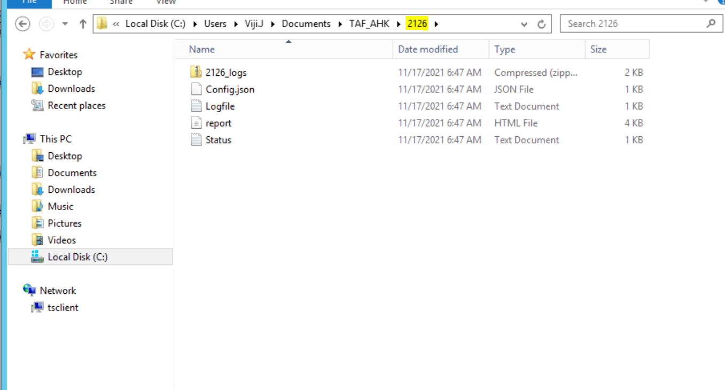

6. We have successfully validated the deployed AHK service application.

**(II) Testing the Deployed application with Sample AHK from TAF:**

1. Check the reachablity from the TAF to AHK VM.

* + 1. IP address should be reachable from the client TAF VM.
    2. 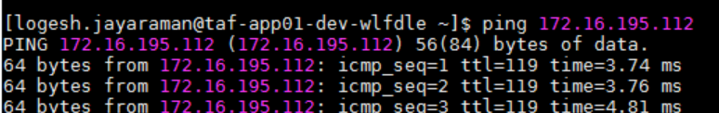
    3. As we have configured the tomcat port as 8080, this port also must be opened to the access from TAF.
    4. 

1. Run the same above cURL command from the TAF VM and check getting the http response code as 200.

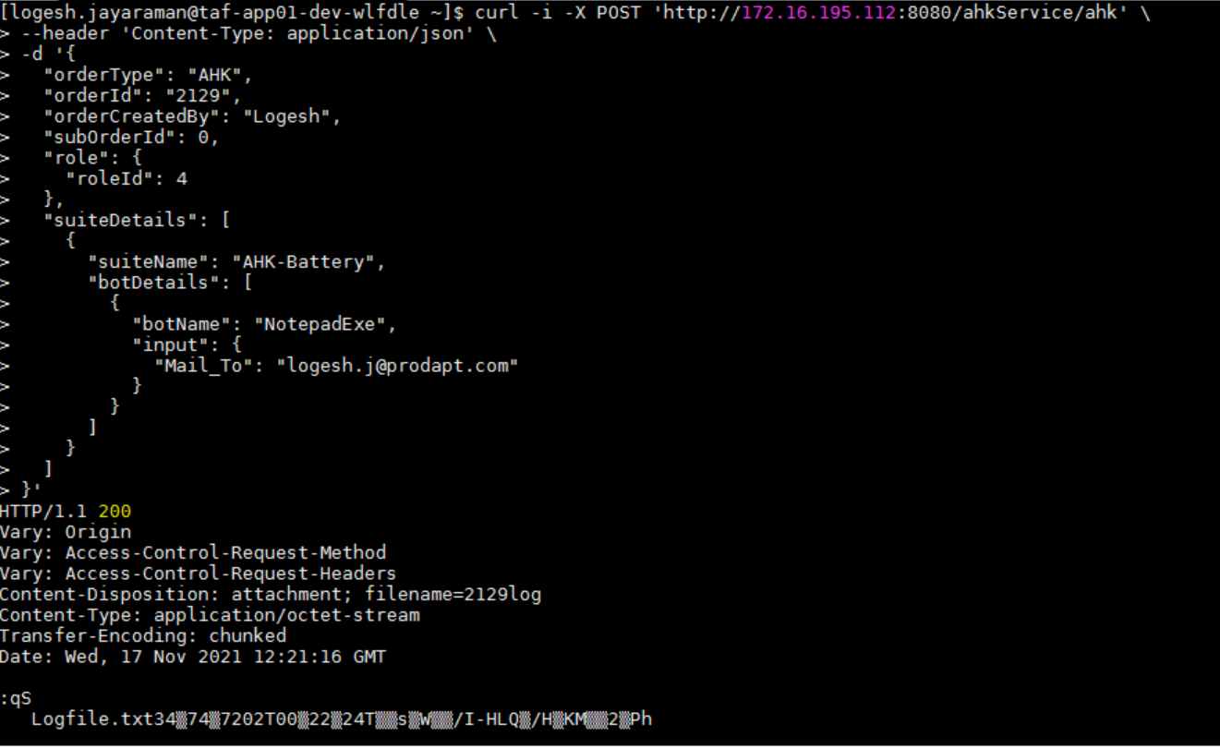

**Ex**: curl -i -X POST 'http://172.16.195.112:8080/ahkService/ahk' \

--header 'Content-Type: application/json' \

-d '{

"orderType": "AHK",

"orderId": "2129",

"orderCreatedBy": "Logesh",

"subOrderId": 0,

"role": {

"roleId": 4

},

"suiteDetails": [

{

"suiteName": "AHK-Battery",

"botDetails": [

{

"botName": "NotepadExe",

"input": {

"Mail_To": "logesh.j@prodapt.com"

}

}

]

}

]

}'

1. After successful 200 response, check the order folder is created in the windows VM and the logs files are available. If all are available then our testing of TAF Sanity execution to AHK is done.